
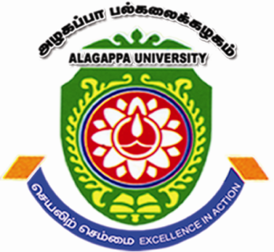

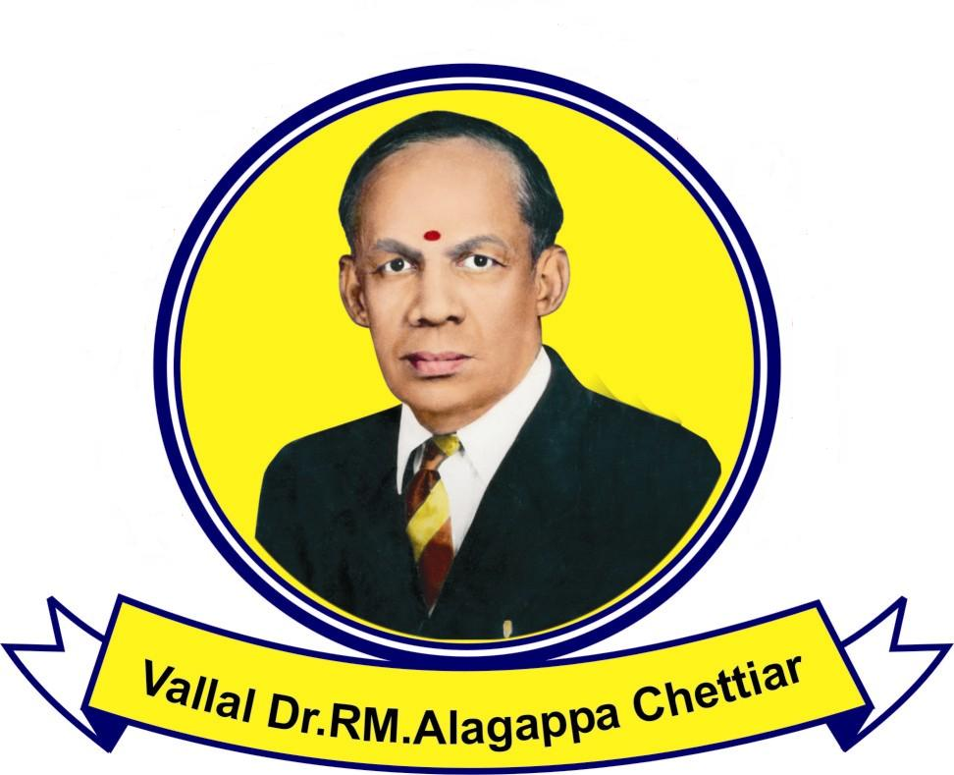

Department of Science and Technology (DST), Government of India sponsored INSPIRE Internship Program for XI standard students

Alagappa University, Karaikudi is organizing a residential Science Camp, INSPIRE (Innovation in Science Pursuit for Inspired Research) Internship Program, sponsored by the Department of Science and Technology, Government of India during September 06 to September 10, 2013 to nourish the curiosity of students in Science, help them think and attract at an early age of 16-17 years (i.e. XI standard) to enroll in the science subjects. To apply for this Camp, the XI standard students should have the following eligibility framed by the Department of Science and Technology, Government of India. The last date for submission of Registration Form which is attached herewith is on or before 30.08.2013. Boarding and lodging will be arranged for the students in the University premises.

Eligibility Criteria for the Applicants:
a) Top one percent ranking in the X Board Examination (for all Boards)
- (Top 1% Percentage - Cut-Off Marks for State Board is 94.2%; CBSE is CGPA-A1 and ICSE is 95.0%).
- Minimum marks scored in X standard (State board) to apply for this programme is 471 out of 500.
b) Pursuing Science in Standard XI
c) Not attended a similar Science Camp elsewhere earlier
d) Participating students shall be within Tamilnadu State

Interested students may download the Registration Form which is attached herewith, fill up and send the filled in Registration Form to Prof. P. MANISANKAR, Programme Coordinator, INSPIRE Internship-2013, Department of Industrial Chemistry, Alagappa University, Karaikudi-630003 on or before 30.08.2013 through their School Principal/ Headmaster/ Headmistress.

For further details, kindly contact
Prof. P. MANISANKAR
Head of the Department
Department of Industrial Chemistry
Alagappa University
Karaikudi-630003
Phone: 04565 228836
Mobile:09443443287
Email: manisankarp@alagappauniversity.ac.in (or) pms11@rediffmail.com

